**Personal Resources Management for Migrants, Trainers, Guiders and Assessors**

**The CAMPLUS Manual**

**and Glossary**

*2nd revised and updated edition*

(Excerpt)

Ruud Duvekot & Kees Schuur

**Colofon**



*Title* **The CAMPLUS Manual and Glossary**

***Personal Resources Management for migrants, trainers, guiders and assessors***

*2nd revised and updated edition*

*Authors*Ruud Duvekot & Kees Schuur

*Design cover* Liesbeth Duvekot

*Styling* https://www.hannievandenberg.nl

*Published by* CL3S, for European Centre Valuation Prior Learning (EC-VPL)

*Download* <https://cl3s.nl/publications/>

<https://drive.google.com/drive/u/1/folders/1YknAZ-aXrnHcNnkGMQtVEa_CPSRH4QPX>

*Funded by the European Union. Views and opinions expressed are however those of the author(s) only and do not necessarily reflect those of the European Union or the European Education and Culture Executive Agency (EACEA). Neither the European Union nor EACEA can be held responsible for them.*

|  |  |  |
| --- | --- | --- |
|  | **CAMPLUS Empowerment for migrants from camps to integration**  2021-1-FR01-KA220-ADU-000028439 |  |

|  |  |  |  |  |
| --- | --- | --- | --- | --- |
|  | |  | |  |
|  | All exercises are licensed by the European Centre Valuation Prior Learning (EC-VPL) for the Swiss CH-Q model of career management: [*https://ec-vpl.nl/ch-q*](https://ec-vpl.nl/ch-q) | | ..\CH-Q logo ROOD.bmp | | |

|  |  |
| --- | --- |
| © 2023, CL3S, EC-VPL  All rights reserved. This publication may be reproduced, translated, stored or transmitted in any form under strict conditions of quotation of sources, publisher and authors.  ISBN 9789492085214 |  |

# Training Module 2: strengthening competences

#### The purpose of this module

The goal of this module is to learn to use and strengthen the ‘recognised’ competences - articulated as one's personal strengths and development points. In this module the ways of working for filling-in the personal portfolio-format is a red threat through the exercises, since all outcomes of the exercises will be made available for entry into one’s portfolio.

#### Learning objectives

* Create a basis for individual development and career planning.
* Sustainable self-management of competences.
* To support self-directed learning and acting.
* Stimulating yourself and others (children, colleagues, friends, family) to document and reflect upon one’s professional and personal development.
* Composing a personal portfolio and an action plan.
* Dealing with and using feedback.
* Quality assurance through professional guidance and proven career tools.

#### Learning outcomes

1. Getting a good grip on how to work out a personal portfolio.
2. Being able to articulate a learning need on the (self-)assessment of one’s personal experiences.
3. Reaching an appropriate level of empowerment for ‘raising one’s own voice’, steered by self-valuing of one’s personal experiences, both by reflecting on one’s own behaviour and on the reflection of others on one’s behaviour.

#### Timetable

Following this module will take 4-5 hours of group work and 2-3 hours of homework.

|  |
| --- |
| **Module 2: strengthening competences** |
| Preparation Module 2:   * *Preparing a personal pitch on one’s major selling points* * *Getting good understanding of the personal portfolio format (see Source 2; chapter 11)* * *Read Source 3: Duvekot & Valdés-Cotera* |
| M2.1 Impressions - Personal development and personal tests |
| M2.2 Core quadrant |
| M2.3 Commercial: promote yourself (personal pitch) |
| M2.4 Personal and social values |
| M2.5 Career values |
| M2.6 Job description and career values |

***M2.1 Impressions***

|  |  |
| --- | --- |
| Goal | Get more insight in your strong and not so strong points |
| Time | 25-40 minutes |

In exercise **M1.2** you gathered impressions of you as a person from yourself and important persons in your life.

Make pairs and discuss your findings. You can use the questions below.

* Do you recognise yourself in the strong and not so strong points that other people wrote down?
* Can you ‘prove’ with concrete examples that you possess the qualities mentioned?
* Can you see a bigger picture in the feedback?
* Are there development points that you want to work on? If yes, which? What would you want to do?
* Are there strong points that you want to use more conscious? If yes, which? What would you want to do?
* What was it like for you to get feedback?

N.B. Be aware that later in exercise M3.5 we are going to deepen your competence in providing feedback, feedforward and feedup. For now, just provide feedback in a intuitive manner!

Write down your characteristics or strong points in your portfolio after discussing. Write down as well your development points which you want to focus on in your action plan.

## M2.2 Core Quadrant

|  |  |
| --- | --- |
| Goals | * To be able to name and see your unique core qualities and pitfalls, challenges and allergies * To help others name and see their unique core qualities and pitfalls, challenges and allergies. |
| Time | 30-60 minutes |

In this exercise you are going to make your own core quadrant. Choose a core quality: pitfall, challenge or allergy and write it down. The concept of core qualities and core quadrants is described by Daniel Ofman in ‘Core Qualities, a gateway to Human Resources’, 2004, Scriptum.

Take your characteristics (see M2.1) as the basis for making your core quadrant. The short explanation of the model below can help you develop your core quadrant.

Put your core quadrant in your portfolio.

#### Core Qualities

A core quality is an individual's specific strength, something he/she is good at, or for which he/she is often praised by others. To the person him- or herself it is a matter of course: anyone can do it. It is an inherent quality that can either be suppressed or developed.

Examples: decisiveness, considerateness, carefulness, courage, orderliness, flexibility.

#### Pitfalls

A pitfall is a transformation of a core quality; not the opposite, but 'too much of a good thing'. The positive aspect goes too far, turning a strength into a weakness.

Examples: Helpful becomes meddling. Careful becomes fussy. Flexible becomes capricious.

Yet there is a positive quality behind every transformation. The underlying core quality can be found using a negative label (pitfall).

Examples: someone who acts inflexibly may have decisiveness as a core quality. Someone with an unyielding attitude may be a go-getter at the core.

N.B.: this mainly concerns behaviour: an individual is not really inflexible, but he or she behaves inflexibly.

#### Challenge

A challenge is the positive opposite of a pitfall. Having identified the negative, transformed behaviour, one can start looking for the challenge.

Examples: in a nagging person, the positive opposite is patience (and the core quality decisiveness). And: in a capricious person, the challenge is orderly behaviour (and the core quality flexibility).

The core quality and the challenge are complementary qualities. The objective is to strike a balance between the two. If the challenge is underdeveloped, the core quality must be improved to find the balance. Example: it is not necessary to become less decisive, but to develop more patience, resulting in a patient decisiveness without nagging. Or: find a balance between flexibility and orderliness.

#### Allergy

The core qualities can also be used to identify potential conflicts with the environment. People tend to be allergic to too much of their own challenge in other persons. The allergy is 'too much of a good thing' of the challenge, as well as the negative opposite of the core quality.

Example: the negative opposite of the core quality decisiveness is passiveness. Too much patience may also degenerate into passiveness.

The more people are confronted with their own allergy, the greater the risk they run of ending up in their own pitfall.

#### Example: decisive individual starts nagging in response to passiveness in another individual

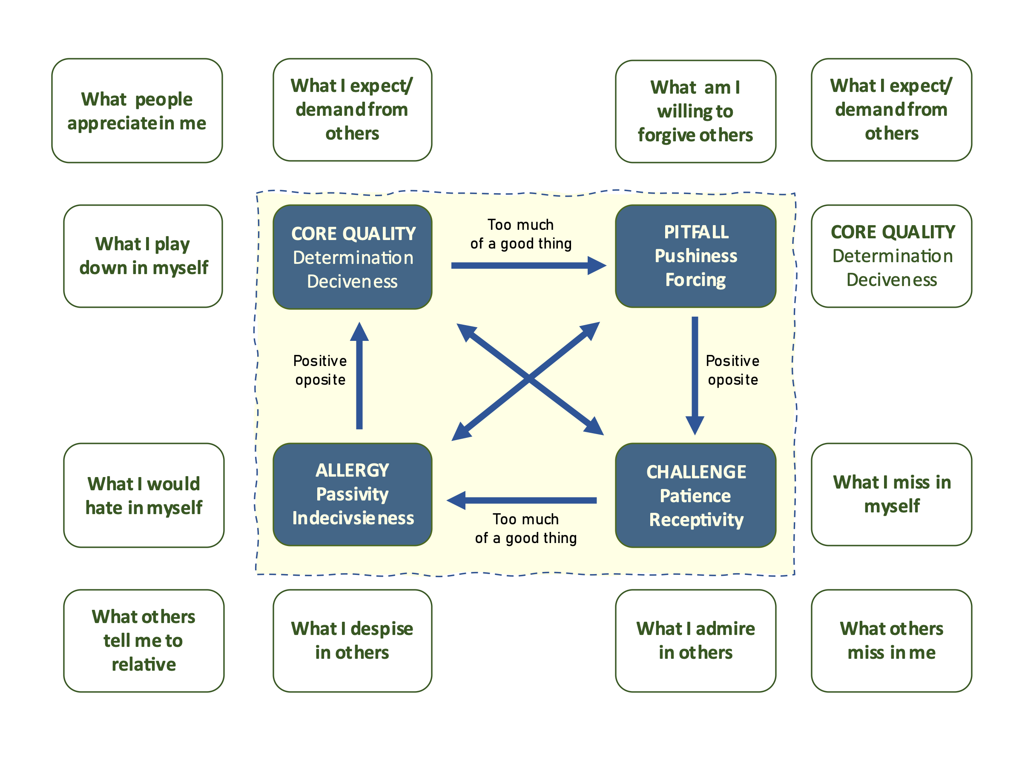

Now, fill it in for yourself: see next page.

#### N.B. Examples

|  |  |
| --- | --- |
| Modest | Invisible |
| Arrogant | Present oneself |

|  |  |
| --- | --- |
| Dedication | Egoism |
| Sacrifice | Helpfulness |

|  |  |
| --- | --- |
| Flexibility | Changeability |
| Rigidity | Consistency |

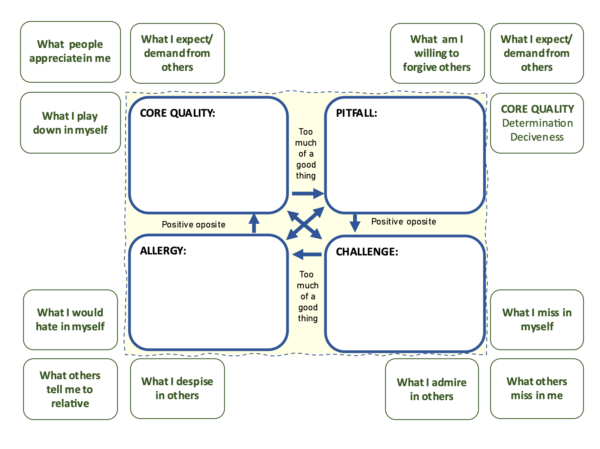

## M2.3 Commercial: promote yourself! (personal pitch)

|  |  |
| --- | --- |
| Goal | * discover more personal qualities * acknowledge your own qualities by talking about them out loud * present yourself and your qualities to others * steppingstone to your presentation on the last day |
| Time | 60-100 minutes |

In a commercial (radio, television, congress), something is promoted. In this exercise, you are asked to promote yourself! It is very powerful to be able to lose your shyness and tell the group about (some of your) your qualities in a promotion or to ´sell´ your qualities/competencies in a job interview.

During the first part of the training, you have written down a number of qualities. And you have discussed them in pairs. Maybe you’ve already discovered a tendency in those qualities.... and you might even have some proof for it. Anyway, now it is time to present yourself in a way that others can learn your most powerful, unique, special, most useful or remarkable quality (or qualities). And you have also already prepared your major selling points for a personal pitch.

If you find it difficult to think of your qualities this way, you could use as a guideline:

* a metaphor which describes you and your qualities
* a symbol which describes you and your qualities
* a hero who represents (most of) the qualities you possess
* or any other guideline

The commercial should last 2-5 minutes, so be short and to-the-point!

**Individual part of this exercise**

Take 20 minutes (maximum) to prepare your commercial.

You can use whatever form you want for this commercial (sing, talk, write, draw, act, slogans, poems et cetera). If you have any questions or need help, just ask other trainees or the trainers.

**In two smaller groups:**

Do your commercial (2-5 minutes).

The others listen. Afterwards, they ask questions and give feedback.

Note: do not forget the feedback rules!

If you want, you can write down the feedback here:

…

…

Also, write down your personal qualities in your portfolio after discussing. ***M2.4 Personal and social values***

|  |  |
| --- | --- |
| Goal | * Becoming aware of values that are most important for you * Gaining insight into the correlation of these values |
| Time | 30-50 minutes |

In this exercise you will use the ‘*List of personal values’* to become aware of your life values.

You work in pairs, with the list of values.

1. The first player starts. Select 10 values that are important in your life. Write them down on cards in front of you. Rank the values in order of importance, starting with the most essential one. Make a note of the result in the scheme below.
2. You will now make a personal values profile by exploring the relationship between the various values. The other player helps you by asking questions or giving feedback. The following questions may assist:

* Do any of the values relate to each other? If so, which ones? Place these together.
* Do any of the values clash? If so, which one(s)? State an example of a situation where values clashed.
* Are any of the values difficult for you to adhere to? If so, which ones and why?

1. Record the result of this 3rd step in the following way:

* Copy the values in exactly the same way as the cards are placed.
* Join clashing values by an arrow.
* Encircle values you have a hard time adhering to.

1. Switch roles and repeat step 1-4.
2. Exchange your views on using this method and state what was most striking about each other’s values profile.

If you have the time, you can use the following deepening questions:

* Are there any values in your profile that can be traced back to your roots (family values)? If so, which are they? Mark these with an x.
* Are there any values other than family values that became important to you because of certain experiences or development? If so, which are they and mark them with a circle? To which experiences or developments do they relate?
* Are there important family values that do not (or no longer) make up part of your profile? If so, which are they? If necessary, use the cards in tracing these values. Which developments or occurrences caused these values to become less important for you?

**List of personal values**

Source: <https://i.pinimg.com/originals/84/79/2d/84792d1adefdcf1068264aa0fe1322e7.png>

**Results**

You now have a list with values which are important for you. Write down the values which are the most important for you. Start with the most important until you have an order of 10 values.

1.

2.

3.

4.

5.

6.

7.

8.

9.

10.

Result step 4: Record your personal values profile

Write down your own conclusions, insights with regards to this exercise (What do you want to remember from this exercise? What have you learnt?) (5 minutes – individual)

|  |
| --- |
| Insights, feelings, other things I want to remember with regards to this exercise |
|  |

## M2.5 Career Values

|  |  |
| --- | --- |
| Goal | Reflecting on career values that are most important for you |
| Time | 45-70 minutes |

Suppose someone asks you what your ideal job looks like. Could you enumerate what you would like to see back in it? What would at least be necessary before you would say ‘yes’ to another job?

That what you regard as very important in your work, are career values. The values tell something about your motives and how you experience life.

When you are working on your own career actively, it is important to know which career values are important for you. Clarifying them is not only important for seeking another job. It is useful anyway to reflect from time to time on your position in your career and life.

Below you see a list of career values. Mark the values that are important for you in your career. You can mark as many values you like. Keep in mind that it’s not about your actual job or abilities but about an ideal situation in which you are able to potentially fulfill all values.

|  |  |  |
| --- | --- | --- |
| 1. | INDEPENDENCE | Be able to determine nature of work without significant direction from others; not have to follow instructions or conform to regulations. |
| 2. | EXERCISE COMPETENCE | Demonstrate a high degree of proficiency in job skills and knowledge; show above-average effectiveness. |
| 3. | CREATIVE EXPRESSION | Be able to express in writing and in person my ideas concerning job and how I might improve it; have opportunities for experimentation and innovation. |
| 4. | CHALLENGING PROBLEMS | Engage continually with complex questions and demanding tasks, trouble-shooting and problem-solving as core part of job. |
| 5. | JOB TRANQUILITY | Avoid pressures and "the rat race" in job role and work setting. |
| 6. | WORK UNDER PRESSURE | Work in time-pressured circumstances, where there is little or no margin of error, or with demanding personal relationships. |
| 7. | PHYSICAL CHALLENGE | Have a job that requires bodily strength, speed, or dexterity, or agility. |
| 8. | STATUS | Impress or gain the respect of friends, family and community by the nature and/or level of responsibility of my work. |
| 9. | SECURITY | Be assured of keeping my job and a reasonable financial reward. |
| 10. | PRECISION WORK | Deal with tasks that have exact specification, that require careful, accurate attention to detail. |
| 11. | INTELLECTUAL STATUS | Be regarded as very well-informed and a strong theorist, as one acknowledged "expert" in a given field. |
| 12. | CHANGE AND VARIETY | Have work responsibilities frequently changed in content and setting. |
| 13. | KNOWLEDGE | Engage myself in pursuit of knowledge, truth and understanding. |
| 14. | FAST PACE | Work in circumstances where there is high pace activity and work done rapidly |
| 15. | ADVANCEMENT | Be able to get ahead rapidly, gaining opportunities for growth and seniority from work well-done. |
| 16. | AESTHETICS | Be involved in studying or appreciating the beauty of things, ideas, etc. |
| 17. | EXCITEMENT | Experience a high degree of stimulation or frequent novelty and drama on the job. |
| 18. | WORK ON FRONTIERS OF KNOWLEDGE | Work in research and development, generating information and new ideas in the academic, scientific, or business communities. |
| 19. | WORK ALONE | Do projects by myself, without any amount of contact with others. |
| 20. | FRIENDSHIPS | Develop close personal relationships with people as a result of work activity. |
| 21. | PUBLIC CONTACT | Have a lot of day-to-day contact with people. |
| 22. | INFLUENCE PEOPLE | Be in a position to change attitudes or opinions of other people. |
| 23. | MAKE DECISIONS | Have the power to decide courses of action, policies, etc. -- a judgment job. |
| 24. | AFFILIATION | Be recognised as a member of a particular organization. |
| 25. | HELP OTHERS | Be involved in helping people directly, either individually or in small groups. |
| 26. | POWER AND AUTHORITY | Control the work activities or (partially) destinies of others. |
| 27. | COMPETITION | Engage in activities which pit my abilities against others. |
| 28. | STABILITY | Have a work routine and job duties that are largely predictable and not likely to change over long period of time |
| 29. | HELP SOCIETY | Do something to contribute to the betterment of the world. |
| 30. | CREATIVITY (GENERAL) | Create new ideas, programs, organised structures or anything else not following format developed by others. |
| 31. | COMMUNITY | Live in a town or city where I can meet my neighbours and become active in local politics or service projects. |
| 32. | LOCATION | Find a place to live (town, geographic area) conducive to my lifestyle, a desirable home base for my leisure, learning, and work life. |
| 33. | PROFIT, GAIN | Have strong likelihood of accumulating large amounts of money or other material gain through ownership, profit-sharing, commissions, merit pay increases and the like. |
| 34. | TIME FREEDOM | Have responsibilities I can work at according to my time schedule; no specific working hours required. |
| 35. | ARTISTIC CREATIVITY | Engage in creative work in any of several art forms. |
| 36. | SUPERVISION | Have a job in which I am directly responsible for work done by others. |
| 37. | RECOGNITION | Get positive feedback and public credit for work well done. |
| 38. | WORK WITH OTHERS | Have close working relations with group; work as a team to common goals. |
| 39. | ADVENTURE | Have work duties which involve frequent risk-taking. |
| 40. | MORAL FULFILLMENT | Feel that my work is contributing to ideals I feel are very important. |
| 41. | HIGH EARNINGS ANTICIPATED | Be able to purchase essentials and the luxuries of life I wish. |
| 42. |  |  |
| 43. |  |  |
| 44. |  |  |
| 45. |  |  |

Now you have a list with values which are important for you. Choose seven values which are the most important for you. Write them down below in order of importance.

1.

2.

3.

4.

5.

6.

7.

Write down your own conclusions, insights with regards to this exercise (What do you want to remember from this exercise? What have you learnt?) (5 minutes – individual)

|  |
| --- |
| Insights, feelings, other things I want to remember with regards to this exercise |
|  |

## M2.6 Job Description and Career values

|  |  |
| --- | --- |
| Goal | Evaluate your career values to how they fit with your life values and with your current job from your job description |
| Necessary time | 45-70 minutes |

What is the job description of your current job? As preparation we have asked you to take – or make – a description.

In this exercise we will examine how well this job description (your job) fits with your Career Values. In addition, you can reflect on the perspective of your life values and how thy match with your career values. The aim is that you briefly reflect on the relation between your life values, career values and the values that are demanded in your current job. How well do they fit. Where are the discrepancies?

**Compare your career values with your job description**

In this exercise you will match your personal (career) values with the values that hold in your current job. You can use your job description to extract the most important career values of your current job. Weigh these values against each of your prioritised values in exercise ‘career values’ and note whether your values support, negate, apply equally, or appear irrelevant to your own values.

|  |  |  |  |
| --- | --- | --- | --- |
|  | Life Values | Values from job description | Career values from exercise |
| 1. |  |  |  |
| 2. |  |  |  |
| 3. |  |  |  |
| 4. |  |  |  |
| 5. |  |  |  |
| 6. |  |  |  |
| 7. |  |  |  |
| Etc. |  |  |  |

#### Conflicts with Career Decision

Look over your list of prioritised values and determine the areas that conflict with your career or values. If there are any conflicts, determine ways to resolve your values conflicts.

…

…

You can also reflect on how the competences and qualities you discovered match with those required in your current job:

…

…

As result of my learning on this exercise, I plan to …

…

…

### Sources

Billett, S. (2001). *Learning in the workplace. Strategies for effective practice.* Crows Nest, Allen & Unwin.

Cedefop (2008). *Terminology of European education and training policy*. Luxembourg: European Communities.

Coalitie voor inclusive: <https://coalitievoorinclusie.nl/vn-verdrag-handicap/wat-is-inclusie/>

Duvekot, R.C. (2016). *Leren Waarderen. Een studie van EVC en gepersonaliseerd leren. Proefschrift.* Houten, CL3S. [thesis, *Valuing Learning. A study of VPL and personalised learning*] <http://cl3s.com/leren-waarderen-download/>

Duvekot, R.C., Kleijer, C., Kortas, J., Ruijgrok, C. & Vijgen, M. (2021). *Dialogisch Valideren in de klas. Leren reflecteren voor en door leerlingen in het primair en voortgezet onderwijs. Handboek voor de leraar.* Houten/Utrecht*,* CL3S/HU.

Duvekot, R.C. & Schuur, C.C.M. (eds.) (2014). *Building Personalized Learning. A handbook for creating a common theoretical background.* Vught, EC-VPL, **Series VPL Biennale 3**. <https://ec-vpl.nl/download/entry/76/>

European Centre Valuation Prior Learning, EC-VPL: <https://ec-vpl.nl>.

European Commission: <https://school-education.ec.europa.eu/en/insights/practices/increasing-student-engagement-steam-education>

European Association for the Education of Adults, EAEA: <https://eaea.org/wp-content/uploads/2021/02/What-is-Bildung-pdf-English.pdf>

UNESCO, International Bureau of Education: <http://www.ibe.unesco.org/en/glossary-curriculum-terminology>

UNESCO Institute for Lifelong Learning (UIL) (2012). *UNESCO GUIDELINES for the Recognition, Validation and Accreditation of the Outcomes of Non-formal and Informal Learning.* Hamburg, UIL. <https://uil.unesco.org/lifelong-learning/recognition-validation-accreditation/unesco-guidelines-recognition-validation-and>

UNHCR, United Nations High Commissioner for Refugees, or UN Refugee Agency: <https://www.unhcr.org/glossary/>